JOB DESCRIPTION
Job Title | CreditAdministration Junior Officer | Location | Byblos Bank Syria  SA
Code: |  | Edition | 2
Division | Support Functions | Department | Risk Management
Effective Date | August 2010 | Revised Date | September 2011
Employee Name |  | Starting Date

1- JOB PURPOSE
Set limits, conditions and General information on the systems and handle the proper filing of all credit documentation and contracts.

2- LINES OF REPORTING
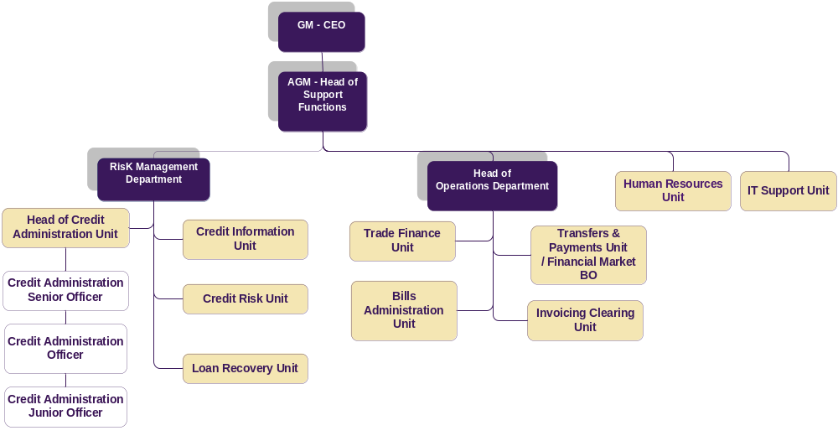

3- ORGANISATION RELATIONSHIP
Byblos Bank Syria :
- Commercial Lending Unit.
- Branch Managers.
- Bills Unit.
- Trade Finance.
- Transfers & payments unit,
- Head of Consumer Lending Unit.
- Head of Credit Administration Unit
- Credit Administration Senior Officer.
- Credit Administration Officer.
- Head of Risk
- Head of Support Functions
- Retail Approval
- Finance.
- Legal

Byblos Bank Lebanon :
- Credit Administration .

External :
- Central Bank

4- DUTIES & RESPONSIBILITIES
Setting the Credits Information on the System Duties and Responsibilities

- Ensure that credit files have been approved according to the procedures in place before inputting any limit on the bank system.
- Set limits, conditions and general information related to credit files on the bank system.
- Issue credit notes related to approved credit files.

Filing Credit Documents and Contracts Duties & Responsibilities
- Ensure that credit files are properly documented, related contracts signed and guarantees constituted in order to authorize the use of approved facilities.
- Maintain credit files and safe keep original documentation of all debtor clients and control their adequacy and timely renewal.
- Handle the archiving of contracts and securities related to closed credit files.

- Implement adequate proactive and risk driven controls.
- Other duties and responsibilities as assigned.

5- JOB REQUIREMENTS
- Education Level:
- BA in Banking , or other related fields

- Experience :
- 1-2 years minimum of banking experience

- Required Competencies:
Technical
- Ability to produce work effectively & efficiently (Quality Service)
- Ability to convey ideas & information in writing using language that is appropriate to both complexity of the topic & understanding of the reader (Writing Skills)

Behavioral
- Ability to identify, meet & exceed internal & external customer expectations (Customer Service)
- Ability to work co-operatively & productively with other members of the team in order to achieve common goals (Teamwork)
- Ability to respond to changing situations by continually improving his/her performance by learning & development (Self Management)
- Ability to take prompt action to accomplish objectives, take decisive actions and be proactive (Initiative)
- Ability & willingness to abide by & respect all the policies & procedures of Byblos Bank (Organizational Awareness)
- Ability to prioritize and allocate time between different tasks in order to achieve goals perfectly (Time Management)

Technical | Behavioral | Managerial | Leadership
Quality Service  TQUS001  1/4  Level: | Customer Service  BCUS002  2/4  Level:
Writing Skills  TWRS006  2/4  Level: | Teamwork  BTEA003  1/4  Level:
Self Management
BBSEM004

1/4
Level:

Initiative
BINI007

1/4
Level:

Organizational Awareness
BORA008
1/4
Level:

Time Management
BTIM011

1/4
Level:

6- WORKING CONDITIONS
- Environmental Conditions:
The job is largely desk based accordingly it does not require significant physical effort and does not expose the job holder to any significant environmental threats.

- Physical Conditions:
The job holder will work in a relatively high pressure environment that requires adherence to various deadlines and the ability to withstand stress.

7- MATERIALS USED
- Tools used in this occupation:
- Computer equipment
- Office
- Telephone

- Technology used in this occupation:
- Office suite software
- Spreadsheet software (e.g. Microsoft Excel)
- Word processing software (e.g. Microsoft Word)
- Presentation software (e.g. Microsoft PowerPoint)
- Electronic Mail Software (e.g. Microsoft Outlook)

I affirm having received, read and understood my Job Description.

Employee Name / Signature & Date

Direct Supervisor Name / Signature & Date

